How To Enable SSL (HTTPS) for IIS 7 Web Server with DocuShare

Secure Sockets Layer (SSL) provides an encrypted communication layer between your web server and client web browsers. DocuShare can be accessed over SSL when used with the IIS Web Server.

**Note:** The **SSL functionality is provided by your web server**, but DocuShare must be informed that SSL is being used so that it will supply SSL-based addresses (https:// instead of http://) in its email notifications that it may send.

SSL may be enabled or disabled any time after DocuShare has been installed.

**Solution**

**Note:** This solution applies to DocuShare 6.x, and 6.5.x

**Note:** This solution applies to Internet Information Server (IIS) 7

**Note:** You must be a Windows Administrator to perform this solution.

**Note:** Please refer to the Microsoft website at _http://www.microsoft.com to obtain the most current information. Search for **How to implement SSL in IIS**. If necessary, contact the vendor directly for additional information.

To Enable SSL (HTTPS) in IIS7:

1.      **Install the Server Certificate.**

**Note:** You will need to install a certificate for your site. Please refer to the Microsoft website at _http://www.microsoft.com to obtain the most current information. Search for **How to implement SSL in IIS**. If necessary, contact the vendor directly for additional information.

a.     From the Start menu, select **Internet Information Services (IIS) Manager**.

b.    In the Internet Information Manager window, select **hostname (your server).**

c.     From the right-hand window pane double click **Server Certificates**. The Server Certificates window pane is displayed.

d.    From the **Actions** pane (on the far right) select **Import**. The Import Certificate window displays.

e.     In the **Certificate file (.pfx)** field enter or select the path to the Certificate and fill out any other required information based on your environment. Then click the **Ok** button.

**Note:** Once the Certificate has been added it should be listed in the Server Certificates window.

2.      **Enable https Binding.**

a.     On the right-hand side select **hostname (your server)** | click the **[+]** sign next to **Sites** | Highlight **Default Web Site**. The Default Web Site Home window pane will display.

b.    Select **Bindings** from the **Actions** window pane on the right-hand side. The Site Bindings window displays.

c.     Select the **Add** button. The Add Site Binding window displays.

d.    From the **Type** drop down menu select **https**. Make any other changes required for your environment.

**Note:** The default https port is 443.

e.     From the **SSL Certificate** drop down menu select the certificate added earlier.

f.     Click the **Ok** button.

3.      **Configure SSL Settings.**

a.     On the right-hand side select **hostname (your server)** | click the **[+]** sign next to **Sites** | Highlight **Default Web Site**. The Default Web Site Home window pane will display.

b.    Double-click the **SSL Settings** icon. The SSL Settings window pane displays.

c.     Put a check mark in the Require SSL checkbox and make any other changes your require for your environment.

**Note:** If Require secure channel (SSL) is not checked, the DocuShare site can be accessed in a non-secured mode.

4.      **Restart IIS.**

**Note:** To change the notification URL address that appears in emails from DocuShare you will need to modify the http_protcol and the http_port value the <dshome>\config\amber.properties file. Changes will not take effect until DocuShare has been restarted.

Double click server certificates

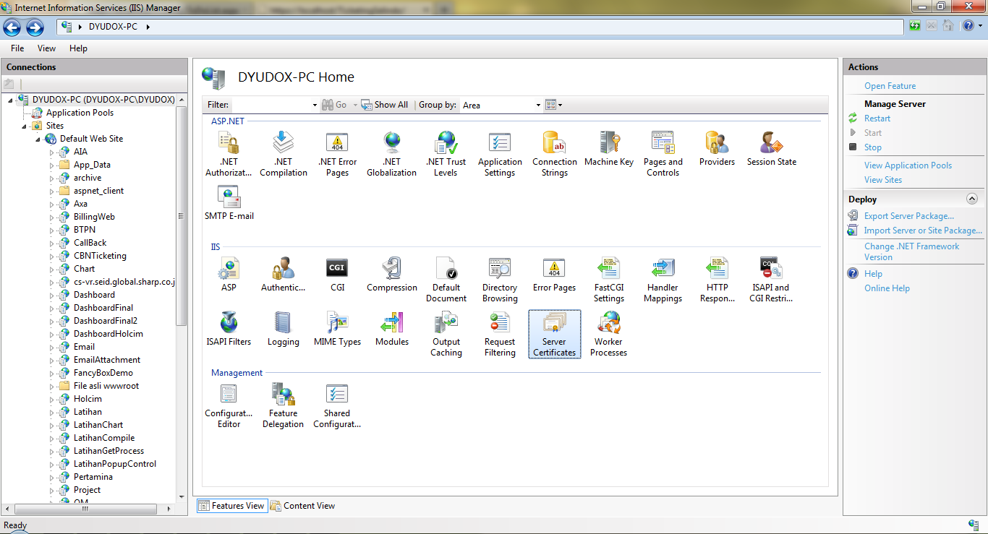

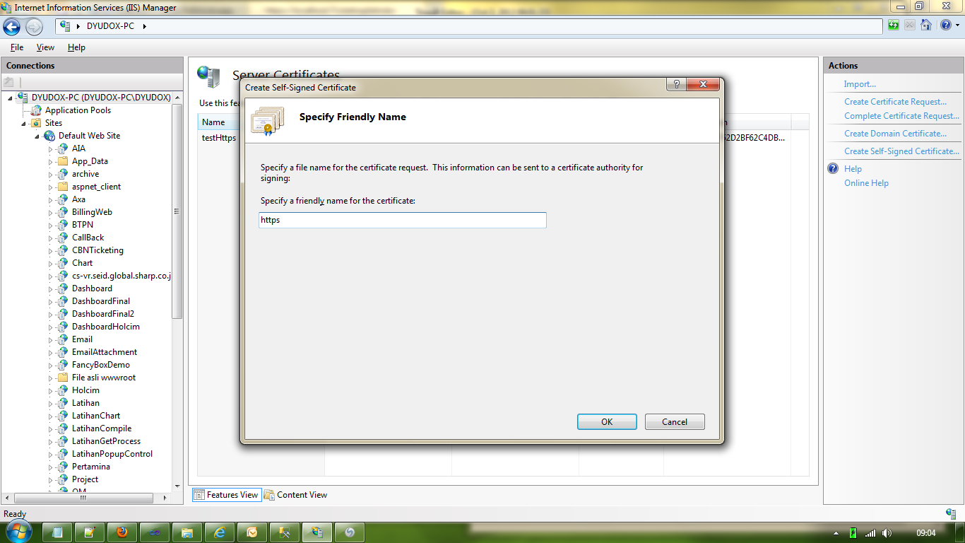

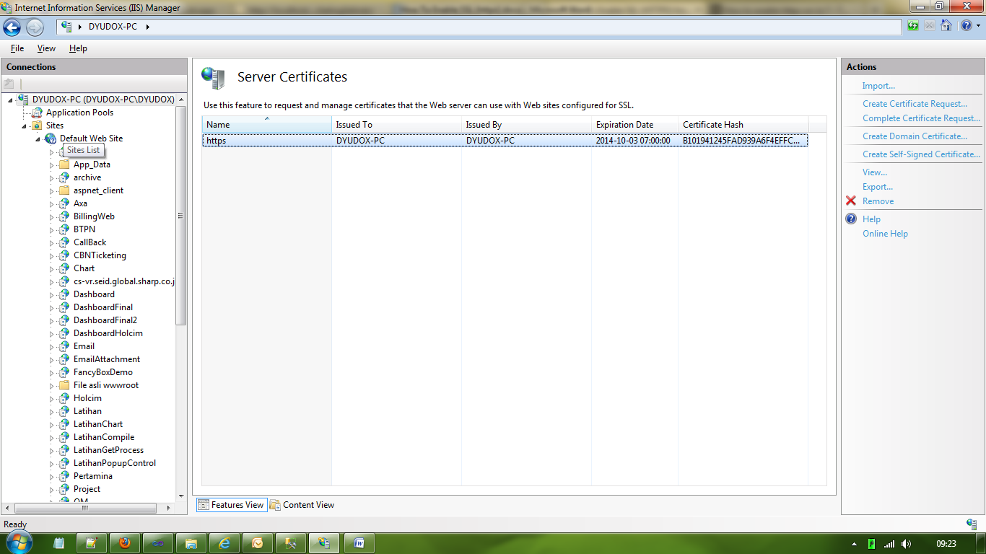

Aktifkan binding

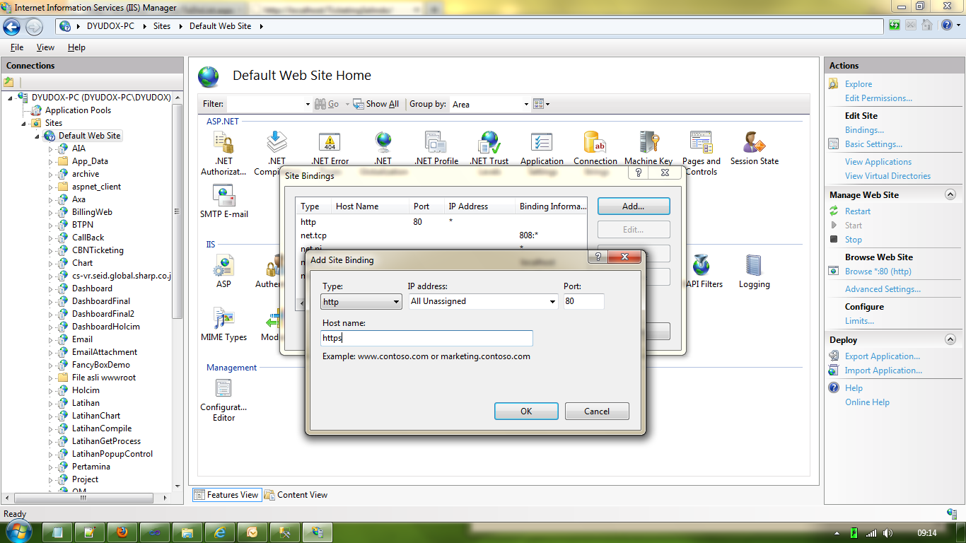

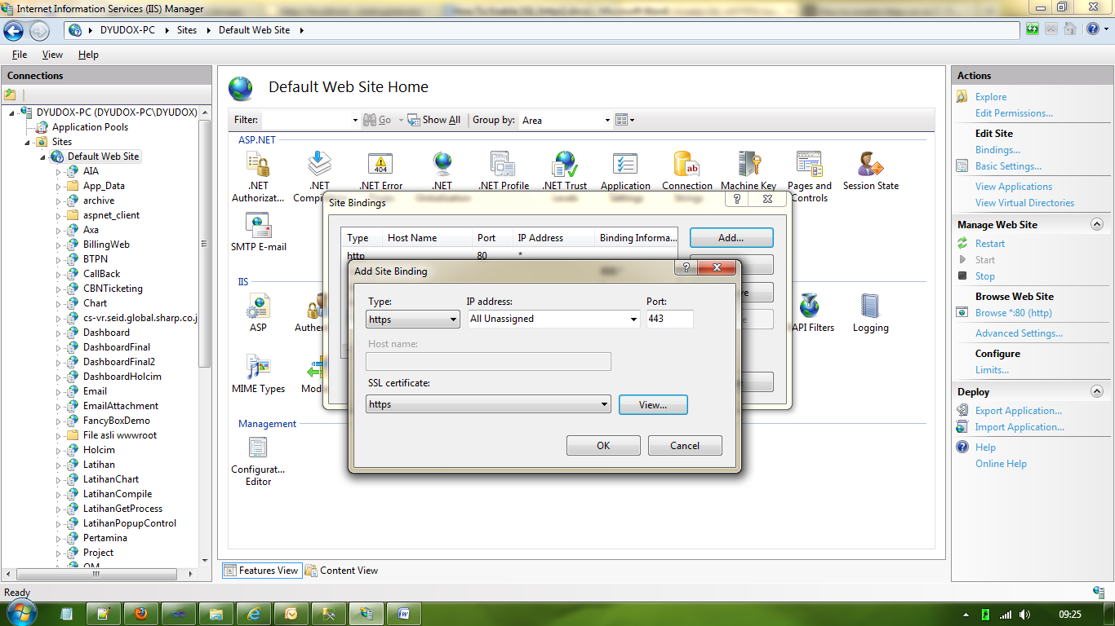

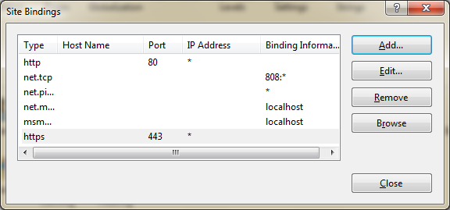

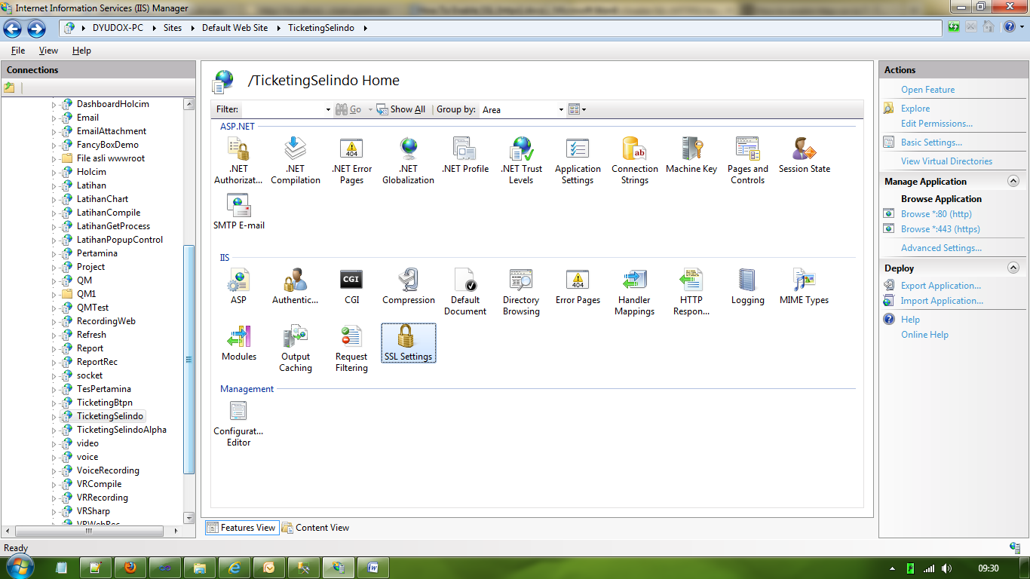

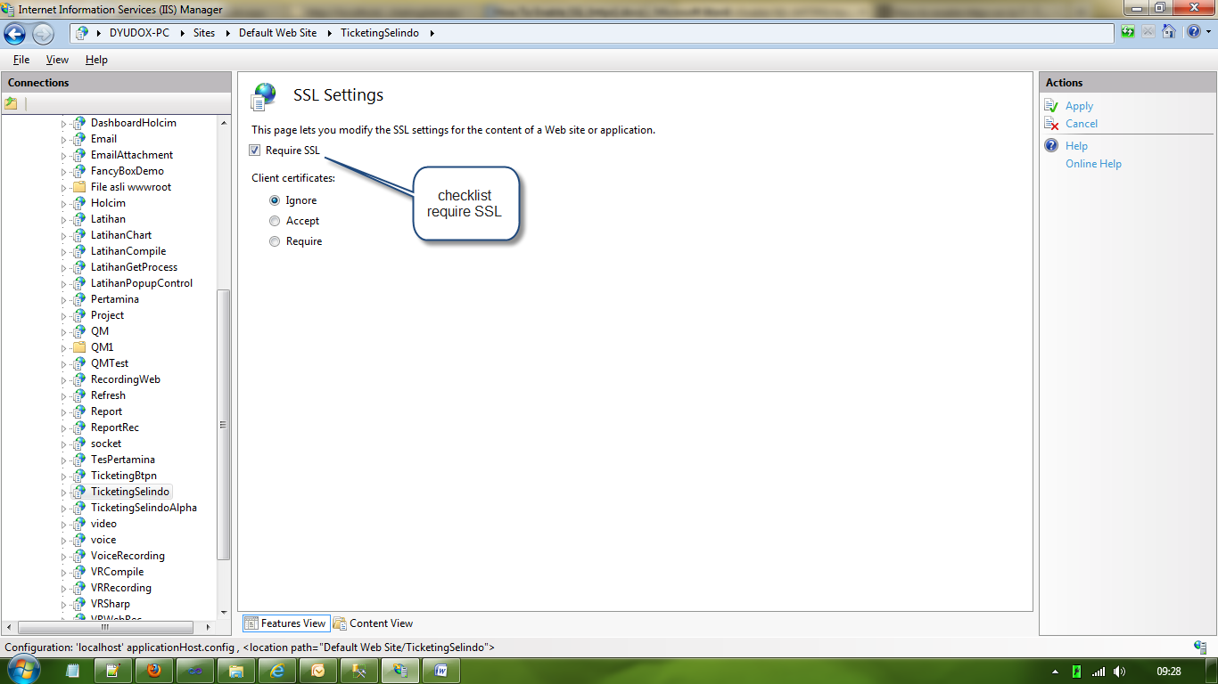

Kemudian pilih websitenya dan setting di advanced setting

